M1 Task 3

Introduction

I am going to explain each of the following and identify why it is important for each of them:

* + - Efficiency
    - Testing
    - Reliability
    - Robustness
    - Usability
    - Portability
    - Maintainability

**Efficiency**

Efficiency is a vital part of the programming world, because it tests how well and efficient the programme is running. For example if the programme is inefficient, it would be confusing as everything would be misplaced and unorganised. Some people may misuse the concept of the programme. Another example, if a user is required to input a numerical but inputs text. This is important, because users like the programme to be efficient and well working.

**Testing**

[](http://www.google.co.uk/url?sa=i&rct=j&q=&esrc=s&frm=1&source=images&cd=&cad=rja&docid=9CNvIDnAvo8dTM&tbnid=PonLRQKg8JUG-M:&ved=0CAUQjRw&url=http://www.megeb.com/how-software-testing-helps-your-application-with-users/&ei=m-5DUraMIJKy7AbCw4HQCw&bvm=bv.53217764,d.ZGU&psig=AFQjCNHeI74nDkJKu7o15jLfmWCnELyAlA&ust=1380270051479497)Testing is when the programme is to outline all the features of the programme to see if everything is working. For example, if a programme is made and one of the button is tested and is not working. The button will need to be fixed and this will be time-consuming. However once the test is complete, it will verify and check any mistakes or errors in the programme to make it sufficient and accurate. This is important, because by outlining the errors, it will identify them and make the whole programme better and faster.

**[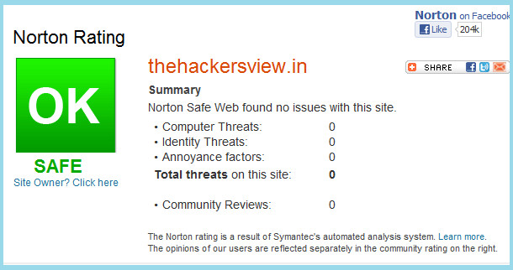](http://www.google.co.uk/url?sa=i&rct=j&q=&esrc=s&frm=1&source=images&cd=&cad=rja&docid=JNJ6MbhMuxpctM&tbnid=JKIRfJTsFrC2gM:&ved=0CAUQjRw&url=http://www.yousaytoo.com/norton-safe-web-online-scanner-scanning-website-for-threats/2033184&ei=CC9EUuvXMI2g7AbXv4DgBA&bvm=bv.53217764,d.ZGU&psig=AFQjCNEmMODzP1Sn1G74_8Xk3GCqHcdGLA&ust=1380286598335071)**

**Reliability**

Reliability simply means it’s consistently of how its run and how trustable the programme is. For example, they can be programmes that can be downloaded and not be run properly. So the user needs to be aware of any viruses the programme that can be sent to the computer. This is important in the programme, because you can check if the programme is trustable by running the programme for any set viruses by your anti-virus.

**Robustness**

Robustness simply means the “health” of the programme. For example, the programme needs to be tested and once it’s tested, the programmer can check if it can take any mistakes. A well written robust program can take the error whereas other programme has to be rebooted or crashes. Robust programmes are easy. This is important, because checking the health of the programme is important. If they is an error in the programme and it hasn’t been tested. It would go wrong and it might cause other errors.

**Usability**

**[](http://www.google.co.uk/url?sa=i&rct=j&q=&esrc=s&frm=1&source=images&cd=&cad=rja&docid=rXWuNQRpMIU2rM&tbnid=l9Of9Ei_P4d-HM:&ved=0CAUQjRw&url=http://zezz.co/services/usability-testing/&ei=MhREUsm-MIKK7AbwyYDYBA&bvm=bv.53217764,d.ZGU&psig=AFQjCNE1VuQKQr826CHymhgJU3UeBxabcA&ust=1380279726622803)**Usability is using your own initiative. For example, during years back when a lot of different programme languages, any time you got to write it you have to do through everything till the end. If it don’t work, you got to go back and find the problem and start again. You can’t stop half way to stop. This is why it’s important, you need to be accurate while you work. Otherwise, you have to go back, find the problem and start again. The importance of this is it needs to be spot on and accurate. Otherwise, they will have to start the programme all over again.

**Portability**

[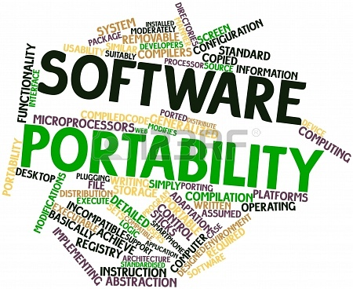](http://www.google.co.uk/url?sa=i&rct=j&q=&esrc=s&frm=1&source=images&cd=&cad=rja&docid=7RiQuVK-b7hBpM&tbnid=erhxauaKf9KTiM:&ved=0CAUQjRw&url=http://www.123rf.com/photo_16617556_abstract-word-cloud-for-software-portability-with-related-tags-and-terms.html&ei=je9DUsC8EKHE7Aa_2oGYAg&bvm=bv.53217764,d.ZGU&psig=AFQjCNEQsGdJjn3hiFIe_HgqDXA1XAgXaQ&ust=1380270294671914)Portability programme are such a way that it won’t take such space. The main advantage is that you can use it in different types of software. Also, it requires a little amount of memory, but the disadvantage is that it runs a little slower.

**Maintainability**

Maintainability are things will change over the years, you many need updated version. You always need to review the program to check if it needs updating. This is important, because if it’s updated regularly. For the program to be updated they could include:

* Technical ability
* Written programmers

These would need to be accurate for it to be satisfied.

For example, in a programme, maintainability is important, because if a user is using the programme and the written aspect is incorrect it would look unreliable.

These both needs to be update and written properly for it to be sustainable.

[](http://www.google.co.uk/url?sa=i&rct=j&q=&esrc=s&frm=1&source=images&cd=&cad=rja&docid=y_qY-xo0wtuK7M&tbnid=n9ARjoZPJxMuAM:&ved=0CAUQjRw&url=http://junixblog.com/junixblog-updating/&ei=Lu9DUtq2OuHC7AbPw4DYDg&bvm=bv.53217764,d.ZGU&psig=AFQjCNGynaYDOmiMXroHpxeq8YrRueC3Lg&ust=1380270247503006)